# UNC Infant 0-1-2 Atlases

Infant Brain Atlases from Neonates to 1- and 2-year-olds

Updates

2013/03/07 Origin is set on ACC (Anterior Commissure Coordinate) as [90 126 72].

2013/02/20 Atlases files are in NIFTI format now, as suggested by Dr. Daniel Glen.

2012/02/20 Label maps have larger coverage now. Note that the label map covers larger region than the brain, so that it has better chance to cover the individual brains after alignment. When you calculate the ROI volume, you can use the segmented individual images as a mask to remove the unnecessary regions.

Files changed: infant-neo-aal.img, infant-1yr-aal.img, infant-2yr-aal.img

2011/11/08. We have updated our atlases by using (a) new segmentation results with surface constraints [1] and (b) new implemented groupwise-HAMMER tool [2].

[1] L. Wang, F. Shi, P.-T. Yap, W. Lin, J. H. Gilmore, and D. Shen, "Longitudinally Guided Level Sets for Consistent Tissue Segmentation of Neonates," Human Brain Mapping, p. In press, 2011.

[2] The groupwise-HAMMER tool is now available with name “GLIRT” at <http://www.nitrc.org/projects/glirt/>.

0. Where to Download

<http://bric.unc.edu/ideagroup/free-softwares/unc-infant-0-1-2-atlases/>

The package is available free to the public for the academic research purpose. Note the ownership, copyright, and all rights are retained by UNC-Chapel Hill.

1. Data and MRI Acquisitions

We constructed 3 atlases dedicated for neonates, 1-year-olds, and 2-year-olds. Each atlas comprises a set of 3D images made up of the intensity model, tissue probability maps, and anatomical parcellation map. These atlases are constructed with the help of state-of-the-art infant MR segmentation and groupwise registration methods, on a set of longitudinal images acquired from 95 normal infants (56 males and 39 females) at neonate, 1-year-old, and 2-year-old (Table 1).

Table 1. Demographic information of the normal infants used in this study

|  |  |  |  |  |  |
| --- | --- | --- | --- | --- | --- |
| Scan | N | Gender | Age at Birth (weeks) | Age at MRI (weeks) | Group |
| First | 95 | 56 m/39 f | 37.9±1.8 (33.4 – 42.1) | 41.5±1.7 (38.7 – 46.4) | Neonate |
| Second |  |  |  | 94.2±3.4 (87.9 – 109.1) | 1-year-old |
| Third |  |  |  | 146.2±4.9 (131.4 – 163.4) | 2-year-old |

Images were acquired on a Siemens head-only 3T scanner (Allegra, Siemens Medical System, Erlangen, Germany) with a circular polarized head coil. For T1-weighted images, 160 sagittal slices were obtained by using the three-dimensional magnetization-prepared rapid gradient echo (MPRAGE) sequence: TR=1900ms, TE=4.38ms, inversion time=1100ms, Flip Angle=7°, and resolution=1x1x1mm3. For T2-weighted images, 70 transverse slices were acquired with turbo spin-echo (TSE) sequences: TR=7380ms, TE=119ms, Flip Angle=150⁰, and resolution=1.25x1.25x1.95mm3. Data were collected longitudinally at 3 age groups: neonates, 1-year-olds, and 2-year-olds. Data with motion artifacts was discarded and a rescan was made when possible. Finally, complete 0-1-2 data of 95 normal infants was acquired.

2. Package Description

Images are distributed at “.hdr”+”.img” format. Please use [MRIcro](http://www.cabiatl.com/mricro/)/[MRIcron](http://www.cabiatl.com/mricro/mricron/index.html)/[SPM](http://www.fil.ion.ucl.ac.uk/spm/) to open.

‘neo’ refers to images at neonate, ‘1yr’ refers to 1-year-old, and ‘2yr’ refers to 2-year-old.

Below lists name convention for neonatal images.

infant-neo.hdr Intensity model (mean image of all 95 registered intensity images)

infant-neo-withSkull.hdr Intensity model with skull

infant-neo-withCerebellum.hdr Intensity model with Cerebellum

infant-neo-seg.hdr Segmentation model

infant-neo-seg-gm.hdr Probability map for GM

infant-neo-seg-wm.hdr Probability map for WM

infant-neo-seg-csf.hdr Probability map for CSF

infant-neo-aal.hdr Label map with 90 ROIs

Fig. 1 shows the above images at a typical axial slice.

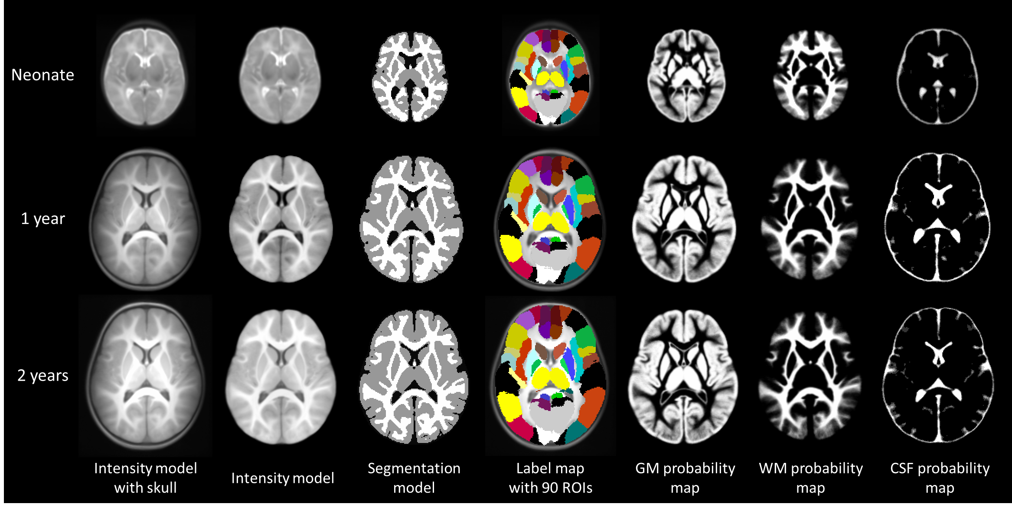

Figure 1. Atlas components for neonates, 1-year-olds, and 2-year-olds.

Intensity/Segmentation models are used to align with individual images, so that the label map can be transferred to individual images.

The anatomical description of regions in “infant-neo-aal.hdr” image is detailed in Table 2. The definition is originally from N. Tzourio-Mazoyer et al, Neuroimage, 15: 273-289, 2002, but now it is warped into infant spaces.

Table 2. Regions of interest (ROI) defined in the infant-AAL template.

|  |  |  |  |  |  |
| --- | --- | --- | --- | --- | --- |
| Index | Region | Abbreviation | Index | Region | Abbreviation |
| 1 | Precentral gyrus left | PreCG-L | **46** | Cuneus right | CUN-R |
| 2 | Precentral gyrus right | PreCG-R | **47** | Lingual gyrus left | LING-L |
| 3 | Superior frontal gyrus (dorsal) left | SFGdor-L | **48** | Lingual gyrus right | LING-R |
| 4 | Superior frontal gyrus (dorsal) right | SFGdor-R | **49** | Superior occipital gyrus left | SOG-L |
| 5 | Orbitofrontal cortex (superior) left | ORBsup-L | **50** | Superior occipital gyrus right | SOG-R |
| 6 | Orbitofrontal cortex (superior) right | ORBsup-R | **51** | Middle occipital gyrus left | MOG-L |
| 7 | Middle frontal gyrus left | MFG-L | **52** | Middle occipital gyrus right | MOG-R |
| 8 | Middle frontal gyrus right | MFG-R | **53** | Inferior occipital gyrus left | IOG-L |
| 9 | Orbitofrontal cortex (middle) left | ORBmid-L | **54** | Inferior occipital gyrus right | IOG-R |
| 10 | Orbitofrontal cortex (middle) right | ORBmid-R | **55** | Fusiform gyrus left | FFG-L |
| 11 | Inferior frontal gyrus (opercular) left | IFGoperc-L | **56** | Fusiform gyrus right | FFG-R |
| 12 | Inferior frontal gyrus (opercular) right | IFGoperc-R | **57** | Postcentral gyrus left | PoCG-L |
| 13 | Inferior frontal gyrus (triangular) left | IFGtriang-L | **58** | Postcentral gyrus right | PoCG-R |
| 14 | Inferior frontal gyrus (triangular) right | IFGtriang-R | **59** | Superior parietal gyrus left | SPG-L |
| 15 | Orbitofrontal cortex (inferior) left | ORBinf-L | **60** | Superior parietal gyrus right | SPG-R |
| 16 | Orbitofrontal cortex (inferior) right | ORBinf-R | **61** | Inferior parietal lobule left | IPL-L |
| 17 | Rolandic operculum left | ROL-L | **62** | Inferior parietal lobule right | IPL-R |
| 18 | Rolandic operculum right | ROL-R | **63** | Supramarginal gyrus left | SMG-L |
| 19 | Supplementary motor area left | SMA-L | **64** | Supramarginal gyrus right | SMG-R |
| 20 | Supplementary motor area right | SMA-R | **65** | Angular gyrus left | ANG-L |
| 21 | Olfactory left | OLF-L | **66** | Angular gyrus right | ANG-R |
| 22 | Olfactory right | OLF-R | **67** | Precuneus left | PCUN-L |
| 23 | Superior frontal gyrus (medial) left | SFGmed-L | **68** | Precuneus right | PCUN-R |
| 24 | Superior frontal gyrus (medial) right | SFGmed-R | **69** | Paracentral lobule left | PCL-L |
| 25 | Orbitofrontal cortex (medial) left | ORBmed-L | **70** | Paracentral lobule right | PCL-R |
| 26 | Orbitofrontal cortex (medial) right | ORBmed-R | **71** | Caudate left | CAU-L |
| 27 | Rectus gyrus left | REC-L | **72** | Caudate right | CAU-R |
| 28 | Rectus gyrus right | REC-R | **73** | Putamen left | PUT-L |
| 29 | Insula left | INS-L | **74** | Putamen right | PUT-R |
| 30 | Insula right | INS-R | **75** | Pallidum left | PAL-L |
| 31 | Anterior cingulate gyrus left | ACG-L | **76** | Pallidum right | PAL-R |
| 32 | Anterior cingulate gyrus right | ACG-R | **77** | Thalamus left | THA-L |
| 33 | Middle cingulate gyrus left | MCG-L | **78** | Thalamus right | THA-R |
| 34 | Middle cingulate gyrus right | MCG-R | **79** | Heschl gyrus left | HES-L |
| 35 | Posterior cingulate gyrus left | PCG-L | **80** | Heschl gyrus right | HES-R |
| 36 | Posterior cingulate gyrus right | PCG-R | **81** | Superior temporal gyrus left | STG-L |
| 37 | Hippocampus left | HIP-L | **82** | Superior temporal gyrus right | STG-R |
| 38 | Hippocampus right | HIP-R | **83** | Temporal pole (superior) left | TPOsup-L |
| 39 | ParaHippocampal gyrus left | PHG-L | **84** | Temporal pole (superior) right | TPOsup-R |
| 40 | ParaHippocampal gyrus right | PHG-R | **85** | Middle temporal gyrus left | MTG-L |
| 41 | Amygdala left | AMYG-L | **86** | Middle temporal gyrus right | MTG-R |
| 42 | Amygdala right | AMYG-R | **87** | Temporal pole (middle) left | TPOmid-L |
| 43 | Calcarine cortex left | CAL-L | **88** | Temporal pole (middle) right | TPOmid-R |
| 44 | Calcarine cortex right | CAL-R | **89** | Inferior temporal gyrus left | ITG-L |
| 45 | Cuneus left | CUN-L | **90** | Inferior temporal gyrus right | ITG-R |

3. How to Use

Typical applications of the infant atlases are the spatial normalization, brain parcellation, and atlas-based segmentation.

**Spatial normalization**: Use registration algorithm to register all your infant subjects to their age-matched atlas (the intensity model).

For registration algorithm, you can choose:

SPM (<http://www.fil.ion.ucl.ac.uk/spm/>),

HAMMER (<http://www.nitrc.org/projects/hammerwml/>),

Demons (<http://www.insight-journal.org/browse/publication/154>).

**Brain parcellation**: Use registration algorithm to register the age-matched atlas to your infant subjects. Then use the generated deformation field to transform the relative AAL map from atlas space to subject space.

**Atlas-based segmentation**:

Using iBEAT. iBEAT (Infant Brain Extraction and Analysis Toolbox) is a MATLAB toolbox we recently developed with modules for state-of-the-art infant brain segmentation and registration. It is available at <http://www.nitrc.org/projects/ibeat>.

Using SPM. Open the SPM in MATLAB environment, click the “Segment” in main menu, click “Data” to choose the to-be-segmented image. For use the infant atlas, Click “Custom”, “Tissue probability maps”, replace the three tissue priors with the age-matched priors, with sequence from “pbmap_1”, “pbmap_2”, to “pbmap_0”. Note that the atlas should be previously well-aligned with the to-be-segmented image (can be done by using the “Coregister” in SPM to warp atlas to your image).

Hint: Use “Check Reg” function in SPM to preview your to-be-segmented image and the infant atlases, make sure their orientations are similar, so that segmentation can be correctly carried out.

4. How It Constructed

In particular, based on the observation that the images acquired at 2-year-olds can be segmented with relative ease and higher accuracy, we use their segmentation results to guide segmentation of images from earlier age groups, i.e., neonates and 1-year-olds. At the same time, longitudinal correspondences across three age groups are also established. With the 2-year-old images as the bridge, the anatomical parcellation, i.e., Automated Anatomical Labeling (AAL) map, is propagated to images of neonates and 1-year-olds. Finally, images at each individual age group are registered cross-sectionally with a groupwise algorithm to form a respective atlas. The obtained infant atlases can be used as references for spatial normalization of a group of infant images, as tissue priors for atlas-based tissue segmentation, and as templates for structural labeling. The effectiveness of our atlases, in comparison with other 3 widely used atlases, is evaluated with typical atlas-based applications. Results indicate that our atlases yield the highest spatial-temporal consistency in spatial normalization and structural labeling of individual infant brain images. Additionally, our atlases give the best performance in atlas-based segmentation of neonatal images.

5. Citation

Please cite our below paper for using the atlas:

Feng Shi, Pew-Thian Yap, Guorong Wu, Hongjun Jia, John H. Gilmore, WeiliLin, Dinggang Shen, "Infant Brain Atlases from Neonates to 1- and 2-year-olds", PLoS ONE, 6(4): e18746, Apr. 2011. doi:10.1371/journal.pone.0018746.

6. Contact

For any questions or bug reports, please email [fengshi@med.unc.edu](mailto:fengshi@med.unc.edu)

Image Display, Enhancement, and Analysis (IDEA) Laboratory

Department of Radiology and Biomedical Research Imaging Center (BRIC)

University of North Carolina at Chapel Hill, NC 27599, USA