These probabilistic masks of the Bed Nucleus of the Stria Terminalis (BNST) are offered for fMRI-based analyses. Individual subject BNST masks were manually created by three raters from 7 Tesla, 0.7mm isotropic, T1 structural scans of 36 healthy adults. These datasets were nonlinearly warped using AFNI's 3dQwarp to the ICBM 2009b Nonlinear Asymmetric template (also called “MNI 152 nonlinear template”): http://www.bic.mni.mcgill.ca/ServicesAtlases/ICBM152NLin2009 . We therefore recommend the use of these BNST masks with this template for group studies. It is highly recommended to visually check your alignment; see figure and citation below for details of anatomical boundaries.

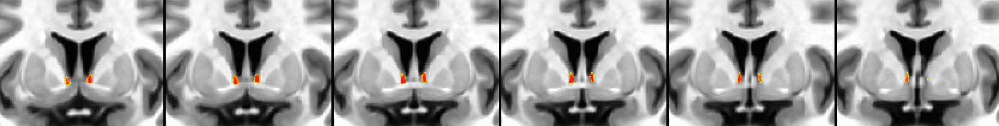
Figure 1: 50% probability map overlaid on high resolution MNI asymmetrical template. Coronal slices from anterior to posterior.

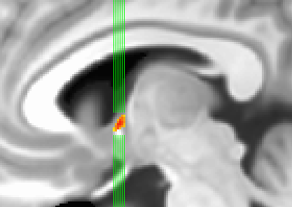
Figure 2: Same threshold, sagittal slice shows location of coronals slices above.

Download all masks from the following link: bnstMasks.tgz

Included in this distribution is:

probbnsts36.nii.gz: unthresholded mask (probabilistic maps stored as floats)

bnsts36_50.nii.gz: Thresholded mask at 50%, stored as bytes.

If one wishes to add these to the whereami program in AFNI for automated identification, modify your .afnirc file like this:

AFNI_SUPP_ATLAS_DIR = ..../bnsts_v1.0
Change the path for the supplemental atlas directory listed above to the path where the directory and the maps actually are installed on your system.

Direct questions and comments to Salvatore (Sam) Torrisi (sam.torrisi @ nih.gov) or Daniel Glen (glend @ mail.nih.gov)

Please cite:
Torrisi, S., O'Connell, K., Davis, A., Reynolds, R., Balderston, N., Fudge, JL., Grillon, C., Ernst, M (2015). Resting state connectivity of the bed nucleus of the stria terminalis at ultra-high field. Human Brain Mapping. Volume 36(10). http://dx.doi.org/10.1002/hbm.22899

Special thanks to Daniel Glen

